Broda O. Barnes, M.D. Research Foundation, Inc.

July 30, 2026

Dear Exhibitor,

The Broda O. Barnes, M.D. Research Foundation, Inc. is pleased to announce that
we will offer exhibit space at our Continuing Medical Education Fall Endocrinology Conference, to be held September 7 - 9, 2007 at the Sheraton Stamford Hotel in
Stamford, Connecticut.
The weekend conference will run from Friday, September 9, at 7:30 a.m. through Sunday,
September 11, ending at 12:00 p.m. Exhibit hours will be Friday, 7:30 a.m. to 6:00 p.m.;
Saturday, 7:30 a.m. to 6:00 p.m.; and Sunday, 8:30 a.m. to 12:00 p.m. All exhibitors
must break down their booths by 2:00 p.m. on Sunday. Each exhibitor will receive
two free conference registrations, which include lunch on Friday and Saturday and dinner
on Friday evening. The cost for exhibit space is $1,300 per single 8-foot tabletop exhibit.
Continental breakfasts and refreshment breaks during the conference will be catered in the exhibit area so that attendees will have maximum exposure to your products and services.
Final booth assignment will be made upon receipt of payment, strictly on a first-come-
first-served basis. All fees must be paid no later than August 15, 2007, and we suggest
that you mail your check or fax credit card registrations as soon as possible. An
Exhibitor’s Service Kit will be sent to you following receipt of your paid reservation.
Enclosed you will find detailed information about exhibit space along with a
registration form, exhibitor information sheet and booth selection floor plan. Please
call the Barnes Foundation at 203-261-2101, fax us at 203-261-3017 or e-mail us at exhibit@brodabarnes.org if you have any questions or need additional information.

BRODA O. BARNES, M.D. RESEARCH FOUNDATION, INC.

POST OFFICE BOX 110098  TRUMBULL, CT 06611  TEL 203-261-2101  FAX 203-261-3017
Exhibitor Fact Sheet
Broda O. Barnes, M.D. Research Foundation, Inc.

Continuing Medical Education
Fall Endocrinology Conference
September 7 – 9, 2007
Sheraton Stamford Hotel  Stamford, Connecticut
For more information, call 203-261-2101, fax 203-261-3017 or e-mail info@brodabarnes.org
Exhibitor Move-In Thursday September 6, 2007 - 6:00 p.m. to 9:00 p.m.
Exhibit Each 8’ tabletop exhibit will be set with skirted table,
Setup two chairs and a wastebasket.
Exhibit Hours Friday September 7 - 7:30 a.m. to 6:00 p.m.
Saturday September 8 - 7:30 a.m. to 6:00 p.m.
Sunday September 9 - 8:30 a.m. to 12:00 p.m.
Exhibitor Move-Out Sunday September 9 - 12:00 p.m. to 2:00 p.m.
Conference Friday September 7 - 7:30 a.m. to 5:00 p.m.
Hours Saturday September 8 - 8:00 a.m. to 5:00 p.m.
Sunday September 9 - 9:00 a.m. to 12:00 p.m.
Hotel Information Sheraton Stamford Hotel
2701 Summer Street
Stamford, CT 06905
(203) 359-1300 (P)
(203) 348-7937 (F)
Make reservations online at: www.brodabarnes.org
Assistance Please call The Barnes Foundation at 203-261-2101,
fax 203-261-3017 or e-mail exhibit@brodabarnes.org
for further information.
Exhibitor Registration Form
Broda O. Barnes, M.D. Research Foundation, Inc.

Continuing Medical Education
Fall Endocrinology Conference
September 7 – 9, 2007
Sheraton Stamford Hotel  Stamford, Connecticut
For more information, call 203-261-2101, fax 203-261-3017 or e-mail info@brodabarnes.org
Register Now!
Registrations will be taken strictly on a first-come-first-served basis.
Don’t miss this opportunity.
YES We would like to exhibit at your 2007 Fall Endocrinology Conference.
Please reserve ______ single 8’ exhibit(s), @ $1,300 per exhibit (includes conference
registration for two people).
Please register ______ additional people from our firm as conference participants
@ $450 per person. (Maximum of two, please.)
Payment method: □ Check/Money order (payable to Barnes Foundation)
□ VISA □ MasterCard □ American Express □ Diners Club
Account # __________ __________ _________ _________ Total $_______________
Expiration date ______/______/_______ Signature ____________________________________________________
The deadline for all registrations is August 15, 2007, and space is limited.
Your payment and booth selection (see enclosed) are necessary to secure your reservation.
Mail payment to: Broda O. Barnes, M.D. Research Foundation, Inc.
P.O. Box 110098 • Trumbull, CT 06611
Company Name ________________________________________________________________
(Exactly as you want it to appear in exhibitor booklet)

Contact Person ____________________________________ Title ________________________
Company Address ______________________________________________________________
City ___________________________________________ State _______ Zip _______________
Phone _________________________________ Fax ___________________________________
Name of Attendee ______________________________________________________________
Name of Attendee ______________________________________________________________
Names of Additional Attendees ___________________________________________________
Product / Service
Information Sheet
Broda O. Barnes, M.D. Research Foundation, Inc.

Continuing Medical Education
Fall Endocrinology Conference
September 7 – 9, 2007
Sheraton Stamford Hotel  Stamford, Connecticut
For more information, call 203-261-2101, fax 203-261-3017 or e-mail info@brodabarnes.org

Company Name ________________________________________________________________
Contact Person ____________________________________ Title ________________________
Company Address ______________________________________________________________
City ___________________________________________ State _______ Zip _______________
Phone __________________________________ Fax __________________________________

To help us maintain the quality and scientific credibility of the products and services offered at the
Broda O. Barnes, M.D. Research Foundation CME Fall Endocrinology Conference, we ask that you furnish
us with a brief description of the products and services you plan to exhibit. The Broda O. Barnes, M.D. Research Foundation, Inc. reserves the right to reject the application of any exhibitor.

Please supply product/service descriptions of no more than two sentences in length. These descriptions will also be used as your listing in the conference exhibitor booklet, so please make sure the wording is exactly as you would like it to appear. Do not send advertisements.
Please type or print.
_____________________________________________________________________________
_____________________________________________________________________________
_____________________________________________________________________________
_____________________________________________________________________________
_____________________________________________________________________________

Booth Selection
Broda O. Barnes, M.D. Research Foundation, Inc.

Continuing Medical Education
Fall Endocrinology Conference
September 7 – 9, 2007
Sheraton Stamford Hotel  Stamford, Connecticut
For more information, call 203-261-2101, fax 203-261-3017 or e-mail info@brodabarnes.org
Please indicate your 1st, 2nd and 3rd choices for booth location in the space provided below. Booths will be assigned in order of receipt of paid reservations, and are strictly on a first-come-
first-served basis. We will do our very best to accommodate everyone’s preferences,
however we cannot guarantee placement.

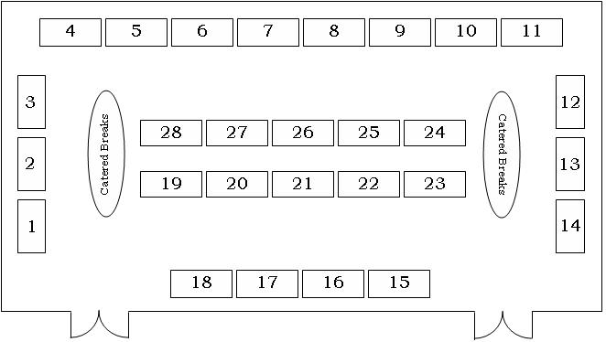

Company Name ______________________________________
________ 1st choice ________ 2nd choice ________ 3rd choice
Any area between 1.________ and 2.________
If none of the above booth choices are available, applicant agrees to accept best alternate assignment.

